Lab 4-1 Implementing a Helper Table
Goals | To configure a helper table in Siebel Analytics and validate its configuration.
Scenario | Requirements have been gathered suggesting that sales deals are executed and owned at different levels within the organization. Management would like to know which managers are responsible for what sales and returns per their sales reps’ efforts. The data warehouse team has created a helper table to support the requirement and you will implement this table in the Siebel Analytics repository.
Time | 40 – 50 minutes
Environment | 
Instructions:
- If necessary, in the Siebel Analytics Administration Tool open ServArchAdv.rpd in online mode and log in as Administrator with no password.
- Create ODBC connections for the W_Position_D dimension table and the W_Position_H helper table data sources.
  - In the ODBC Data Source Administrator dialog box, click the System DSN tab.
  - Click Add.
  - In the Create New Data Source dialog box, select Driver do Microsoft Excel(*.xls) and click Finish.
  - In the ODBC Microsoft Excel Setup dialog box, enter the following:
Data Source Name | W_Position_D
Version | Excel 97-2000
  - Click Select Workbook.
  - In the Select Workbook dialog box, verify that Excel Files (*.xls) is selected from the List Files of Type drop-down menu and navigate to C:\Data\ANADV.
  - Select W_Position_D.xls and click OK.
  - Click OK.
  - Repeat the above steps to create a data source named W_Position_H for the C:\Data\ANADV\W_Position_H.xls data source.
  - Click OK to close the ODBC Data Source Administrator dialog box.
- Import the data sources into the Siebel Analytics repository file.
  - In the Siebel Analytics Administration Tool, select File > Import > From Database.
  - In the Select ODBC Data Source dialog box, select W_Position_D and click OK.
  - In the Import dialog box, ensure that all of the import options are checked and click Import.
  - Click Close.
  - Repeat these steps to import the W_Position_H data source.
  - Select File > Check In Changes.
  - Select File > Save.
  - Update the row counts on each new data source to verify connectivity.
    - In the Physical layer, expand the W_Position_D data source, right-click the W_Position_D$ table, and select Update Row Count.
    - Click Yes to confirm checkout of the object.
    - With your mouse, hover over the table and verify that it has 7 rows.
    - Update the row count on the W_Position_H$ table and verify that it has 11 rows.
- Define keys and joins in the Physical layer and create an alias of the dimension table to support the business requirements.
  - Define the primary keys for the W_Position_D$ (ID column) and W_Position_H$ (SubID column) tables.
  - The Position table includes records for employees and managers. In order to report on both at the same time, we need to create an alias of the Position table. Create an alias for W_Position_D$ named W_Position_D$ (Manager).
    - Right-click W_Position_D$ and select Copy.
    - Right-click the physical catalog C:\Data\ANADV\W_Position_D and select Paste.
    - Click Yes to check out the object.
    - Double-click the newly-created physical table to open the Physical Table dialog box.
    - Under the General tab, rename the table W_Position_D$ (Manager).
    - Set the table as an alias of the W_Position_D$ table.
      - In the Object Type drop-down list, select Alias.
      - Click Select and, in the Browse dialog box, select the W_Position_D$ table.
      - Click OK. Your screen should appear as follows:
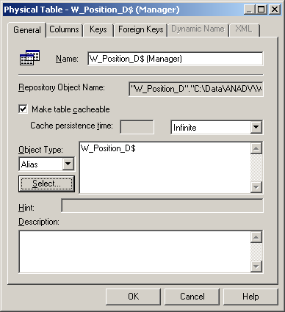
      - Click OK. The W_Position_D$ (Manager) table should appear as follows:
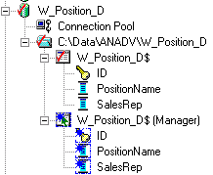
  - Create a one-to-many foreign key join from the W_Position_H$ helper table to the W_Position_D$ dimension table using the SubID and ID columns, respectively. This ties the subordinate position from the helper table to the position ID in the Position dimension table.
    - Select the W_Position_H$ and W_Position_D$ tables.
    - Right-click either table and select Physical Diagram > Selected Object(s) Only.
    - Click the New foreign key button.
    - Click the W_Position_H$ table and then click the W_Position_D$ table.
    - In the Physical Foreign Key dialog box, verify that the SubID column of the W_Position_H$ table and the ID column of the W_Position_D$ table are selected.
    - Click OK.
    - Close the Physical Diagram window.
  - Create a one-to-many foreign key join from the W_Position_D$ (Manager) alias to the W_Position_H$ helper table using the ID and PositionID columns, respectively. This ties the Position ID of the manager from the Manager alias to the position ID in the Position dimension table.
    - Select the W_Position_D$ (Manager) and W_Position_H tables.
    - Right-click either table and select Physical Diagram > Selected Object(s) Only.
    - Click the New foreign key button.
    - Click the W_Position_D$ (Manager) table and then click the W_Position_H$ table.
    - In the Physical Foreign Key dialog box, verify that the ID column of the W_Position_D$ (Manager) table and the PositionID column of the W_Position_H$ table are selected.
    - Click OK.
    - Close the Physical Diagram window.
  - Create a one-to-many foreign key join from the W_Position_D$ dimension table to the Returns$ fact table using the ID and PosID columns, respectively. This ties the dimension table to the Returns fact table.
    - Expand the D1_Returns2 data source in the Physical layer to expose the Returns$ table.
    - Select the W_Position_D$ and Returns$ tables.
    - Right-click either table and select Physical Diagram > Selected Object(s) Only.
    - Click the New foreign key button.
    - Click the W_Position_D$ table and then click the Returns$ table.
    - In the Physical Foreign Key dialog box, verify that the ID column of the W_Position_D$ table and the PosID column of the Returns$ table are selected.
    - Click OK.
    - Close the Physical Diagram window.
  - Verify your joins.
    - Select the following tables and open them in the Physical Diagram window: W_PositionD$, W_Position_D$ (Manager), W_Position_H$, and Returns$.
    - Your joins should appear as follows:
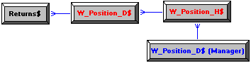
  - Check in your changes and save the repository.
- Map to the Business Model and Mapping layer.
  - Create a logical table called Positions.
    - Select W_Position_D$ from the Physical layer.
    - Drag and drop it onto the SupplierSales subject area in the Business Model and Mapping layer.
    - Click Yes to check out objects.
    - Expand the W_Position_D$ table in the Business Model and Mapping layer.
    - Rename the W_Position_D$ table to Positions by right-clicking it and selecting Rename.
    - Rename the SalesRep column Employee Sales Rep Name by right-clicking it and selecting Rename.
    - Rename the PositionName column Employee Sales Rep Position Name.
    - Rename the ID column Employee ID.
  - Bring the W_Position_D$ (Manager) columns over to the Positions table.
    - Select W_Position_D$ (Manager) in the Physical layer.
    - Drag and drop it onto the Positions logical table.
    - Rename the SalesRep column Employee Sales Rep Manager Name.
    - Rename the PositionName column Employee Sales Rep Manager Position Name.
    - Rename the ID column Manager ID.
  - Configure W_Position_H as a snowflake design into the Business Model and Mapping layer.
    - Open the W_Position_D$ (Manager) logical table source.
      - Expand the Sources folder for the Positions logical table.
      - Double-click the W_Position_D$ (Manager) source.
    - If necessary, in the Logical Table Source dialog box click the General tab.
    - Select the only table listed in the Map to These Tables window.
    - Click Add.
    - In the Browse window, select the W_Position_H$ physical table.
    - Why is the W_Position_H$ table displayed on the right side of the window initially?
    - Click Select.
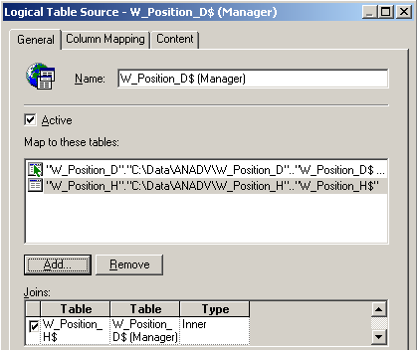
  - Add Positional Hierarchy Gap as a column to the Position logical table. Recall that Gap is a column in the helper table that stores the gap between levels.
    - Click the Column Mapping tab of the Logical Table Source dialog box.
    - Click New Column.
    - Type Positional Hierarchy Gap in the Name field of the Logical Column dialog box.
    - Click OK.
    - Select the Show unmapped columns check box.
    - Click the ellipsis button to the right of the Positional Hierarchy Gap logical column.
    - Select the Gap physical column from the W_Position_H physical table and click Insert. Your screen should look as follows:
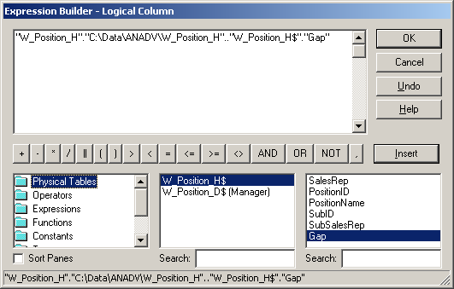
    - Click OK.
    - Click OK.
    - Does W_Position_H$ show up as a logical table source for the Position logical table?
  - Create a dimensional hierarchy.
    - Right-click the SupplierSales subject area and select New Object > Dimension.
    - In the Dimension dialog box, enter PositionDim as the name and click OK.
    - Right-click PositionDim and select New Object > Logical Level.
    - In the Logical Level dialog box, enter TotalPosition as the Name and select the Grand total level check box.
    - Click OK.
    - Right-click the TotalPosition level and select New Object > Child Level.
    - In the Logical Level dialog box, enter Detail as the Name and set the level to have 100 elements.
    - Click OK.
    - Drag and drop the Employee ID and Positional Hierarchy Gap columns from the Positions logical table onto the Detail level of the hierarchy.
    - Double-click the Detail level and click the Keys tab of the Logical Level dialog box.
    - Click New to add a new primary key.
    - In the Logical Level Key dialog box, select the check boxes for Employee ID and Positional Hierarchy Gap.
    - Deselect the Use for drilldown check box.
    - Click OK.
    - Click OK.
  - Create a one-to-many foreign key join between Positions and Returns.
    - Select the Positions and Returns logical tables.
    - Right-click either logical table and select Business Model Diagram > Selected Tables Only.
    - Click the New complex join button, and then click Positions and Returns tables.
    - In the Logical Join dialog box, accept the default.
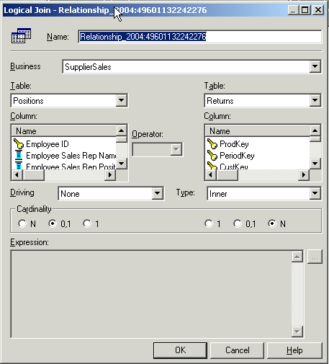
    - Click OK.
    - Close the Logical Table Diagram window.
- Assign the Detail level of the dimensional hierarchy to the Returns fact logical table source. For every fact we need to assign the level of the dimension that it is associated with.
  - Expand the Returns logical table and its sources.
  - Double-click the Returns$ logical table source.
  - Click Yes to check out the objects.
  - In the Logical Source dialog box, click the Content tab.
  - Select the PositionDim dimensional hierarchy you created above.
  - In the Logical Level column for the PositionDim dimensional hierarchy, click the down-arrow button and select the Detail level.
  - Click OK.
  - Check in changes and check consistency.
Note: In some circumstances, the join between Positions and Returns does not automatically convert Positions to a dimension, and the consistency check will fail. If this occurs, delete and re-create the join and the problem should be resolved.
  - Save the repository.
- Map to the Presentation layer.
  - Drag and drop the Positions logical table onto the SupplierSales Presentation layer catalog.
  - Click Yes to check out the objects.
  - Rename the Positions Presentation layer table Employees.
  - Check in your changes and check for consistency.
  - Save the repository.
- Test the Configuration.
  - Log in to Siebel Analytics Web as Administrator with no password.
  - Click Answers.
  - Select the SupplierSales subject area.
  - Answer the business question: How many returned units were associated with each Employee Sales Rep?
    - Select Employee Sales Rep Name and Employee Sales Rep Position Name from the Employees table. Also, select # of Returns from the Returns fact table.
    - Click the Results tab. Your results should appear as follows:
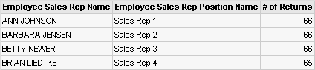
  - Re-execute the request with a filter on Employee Sales Rep Name of Alan Ziff.
  - What are the results?
  - Click the Criteria tab.
  - Create a new request with the following columns: Employee.Employee Sales Rep Manager Name, Employee.Employee Sales Rep Manager Position Name, Returns.# of Returns.
  - Click the Results tab. Your results should appear as follows.
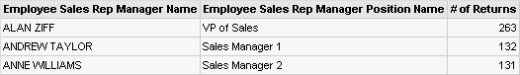
Note that this result does not represent the aggregate number of returns in the sales organization; it is the number of returns for which each manager is responsible. Alan Ziff appears in the results now because members of his management team, Andrew Taylor and Anne Williams, have returns which roll up to him. Also note that if we add the returns that roll up to Andrew Taylor and Anne Williams, the sum should be equal to Alan Ziff’s total number of returns. You have demonstrated the operation of the bridge table by being able to report at different levels of the sales hierarchy without using level-based measures.
- Log out of Siebel Analytics Web and close the browser window.
- Close the Siebel Analytics Administration Tool.
Solutions 4-1 Implementing a Helper Table
Answers
5.c.vi. Why is the W_Position_H$ table displayed on the right side of the window initially?
The join was made in the physical layer between W_Position_H$ and W_Position_D$ (Manager). Analytics knew that link was there but it is necessary to define the relationship in the logical table source.
5.d.x. Does W_Position_H$ show up as a logical table source for the Position logical table?
No, only W_Position_D$ and W_Position_D$ (Manager) are defined. W_Position_H$ does not need to be defined as a logical table source because it is defined implicitly due to the snowflake design that was modeled.
8.f. What are the results?
There are no results for Alan Ziff as an Employee. He is not directly associated with a return.

